**Phase 2: Org Setup & Configuration**

**Salesforce Edition**

* **Edition Used:** Developer Edition is Used.
* **Reason:** Provides full customization capabilities (Objects, Flows, Triggers, Dashboards) free of cost and ideal for building this project.

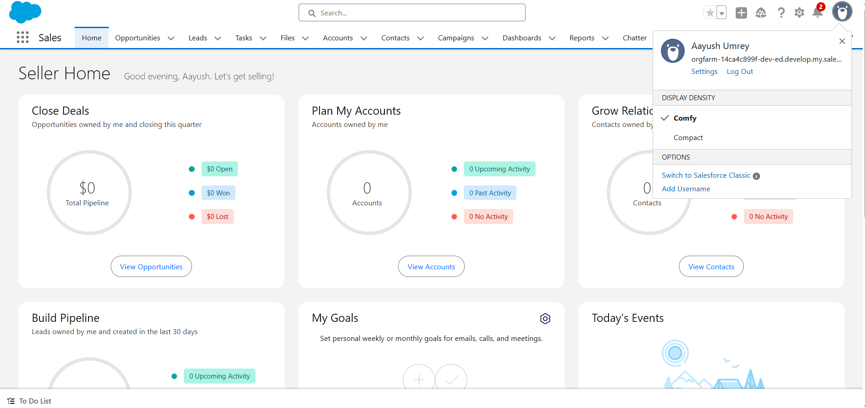

**Company Profile Setup**

1. **Update Company Name:** Orderly - E-commerce CRM.
2. **Configure Default Time Zone:** (GMT+5:30) IST (For India)
3. **Currency:** INR (For India) or Multi Currency For Different Countries.

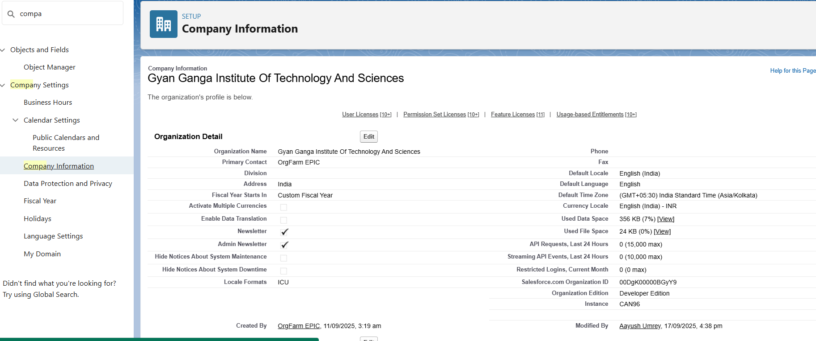

**Business Hours & Holidays**

* **Business Hours:** Mon–Sat, 9:00 AM – 6:00 PM IST
* **Holidays:** Republic Day (26-Jan), Independence Day (15-Aug), Diwali (as per date), ect.
* **Reason:** Ensures any escalations, SLAs, and workflows follow working hours and avoid holidays.

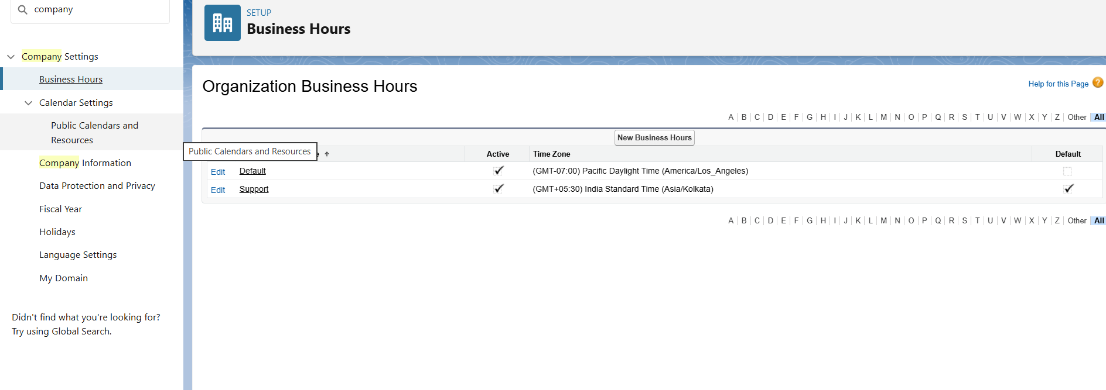

**Fiscal Year Settings**

* **Fiscal Year:** Configure Custom Fiscal Year, April–March (common Indian accounting cycle).
* **Reason:** Aligns sales dashboards and reports with business accounting periods.

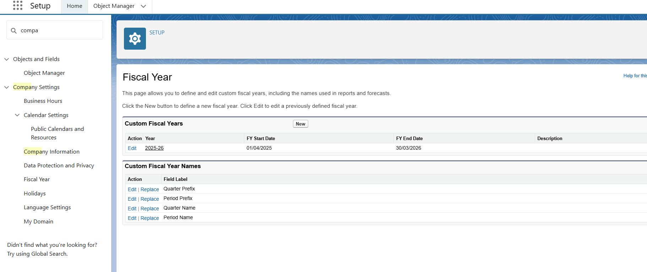

**User Setup & Licenses**

|  |  |  |
| --- | --- | --- |
| User | Role | License |
| CEO / Business Owner | CEO | Salesforce |
| Sales Manager | Sales Manager | Salesforce |
| Warehouse Manager | Warehouse Manager | Salesforce |
| Customer Support | Support | Salesforce |

This Show the user role, responsibility and assign appropriate Salesforce license.

(Screen Shot - Users)

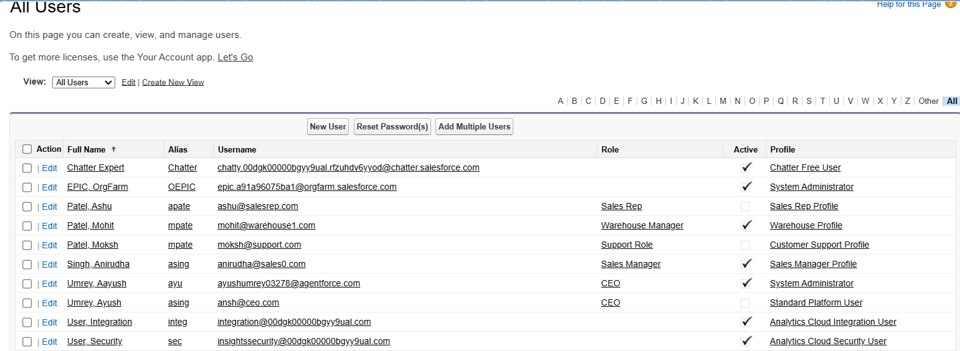

**Profiles**

**Custom Profiles Created:**

* **Sales Profile:** Full access to Orders, limited read access to Inventory
* **Warehouse Profile:** Read/Write on Inventory, read access on Orders
* **Support Profile:** Read-only on Orders, no edit rights
* **Sales Rep** – Likely **Inventory Read Access + Reports Access**, no order approval.

**Reason:** Profiles enforce object- and field-level security for different job roles.



**Role Hierarchy**

|  |  |  |  |
| --- | --- | --- | --- |
| Role | Reports To | Responsibilities | Data Visibility |
| CEO | Top Level | Business owner, strategic decisions | Sees all records (Orders, Inventory, Products) |
| Sales Manager | CEO | Manages sales team, approves orders, monitors sales performance | Sees own orders + orders of Sales Reps |
| Sales Rep | Sales Manager | Creates customer orders, tracks customer data | Sees only own orders |
| Warehouse Manager | Sales Manager | Manages inventory, updates stock, fulfils. orders | Sees all orders (via sharing rule), edits inventory |
| Customer Support | CEO (or directly under Sales Manager if preferred) | Handles order inquiries, updates customers on order status | Read-only access to orders |

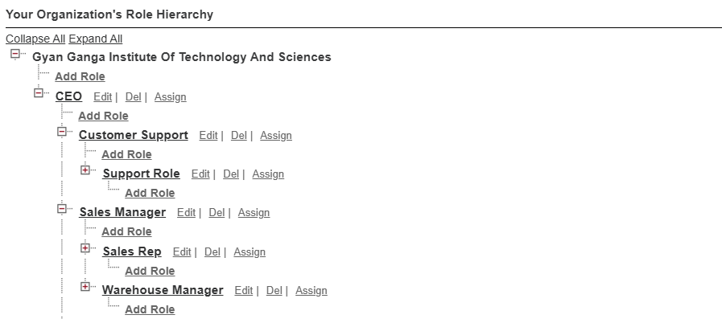

**Permission Set (After Object Creation in Phase 3)**

* **Low Stock Alert Access:** Grants Warehouse Manager access to a custom Dashboard component showing low-stock products.
* **Order Approval Permission:** Allows Sales Manager to approve pending orders before fulfilment.

**Organization-Wide Defaults (OWD) (After Object Creation in Phase 3)**

* Private For Orders to restrict visibility, only owner & hierarchy can view.
* Use Controlled by parent for order items to follow order visibility.
* Inventory public Read/Write.
* Products for public Read only.

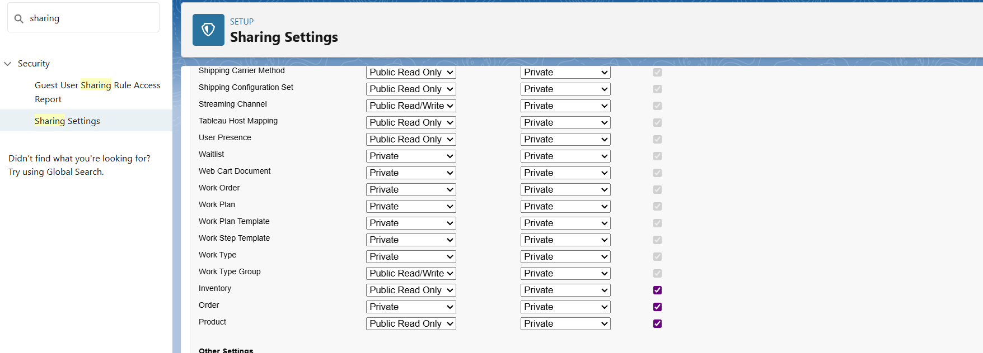

**Sharing Rules (After Object Creation in Phase 3)**

* Share **Orders** owned by Sales Rep share with **Warehouse Manager Role** (Read/Write) so they can fulfill orders.
* Share **Orders** owned by Sales Rep share with **Customer Support** (Read only) so they can see the customer order and resolve problem.

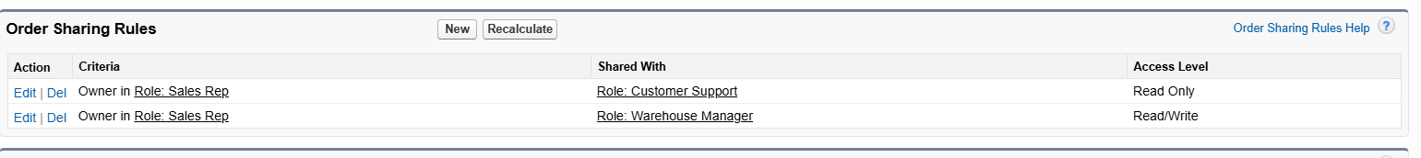

**Login Access Policies**

* Enable Admin login as feature for troubleshooting.
* Set Trusted IP Ranges to secure org access

**Developer Org Setup**

* **Created Custom Lightning App: Orderly App**
* **Added Tabs:** Orders, Order Items, Products, Inventory, Dashboards
* **Customized App Branding:** Company logo & app color theme

**Sandbox Usage**

* **Developer Sandbox** for testing Flows & Triggers
* **Partial Copy** **Sandbox** for UAT
* **Full Sandbox** for pre-production simulation

**Deployment Basics**

* **Change Sets (Admin-Friendly):**
* Select components (Objects, Flows, Profiles, Reports, etc.) and deploy between related Salesforce orgs
* Ideal for smaller, declarative changes
* **Salesforce DX / CLI (Developer-Friendly):**
* Push/pull components from local project folder
* Ideal for Apex, LWCs, and large development teams